1. Setup java
2. Setup IDE
3. Setup Database in application.properties file
4. spring.jpa.hibernate.ddl-auto = update ( Change to Create for First Time)
5. Run Application (Spring Boot so You need to run as a Application )
6. Open Browser localhost:8080

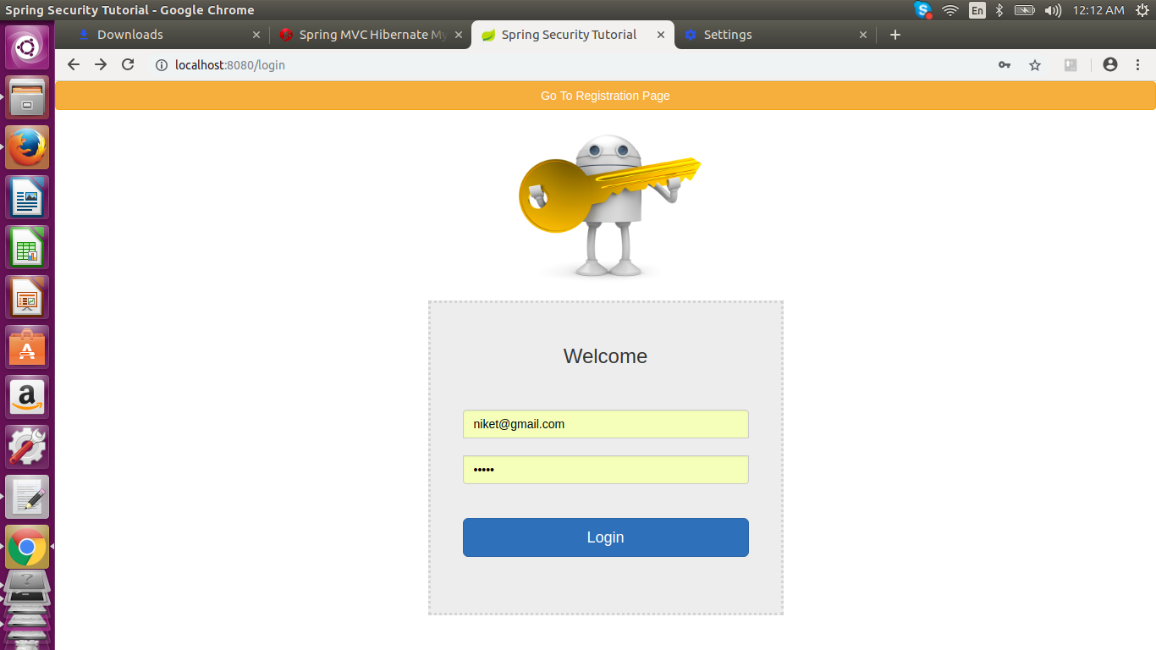

7. Before Login Register with Application

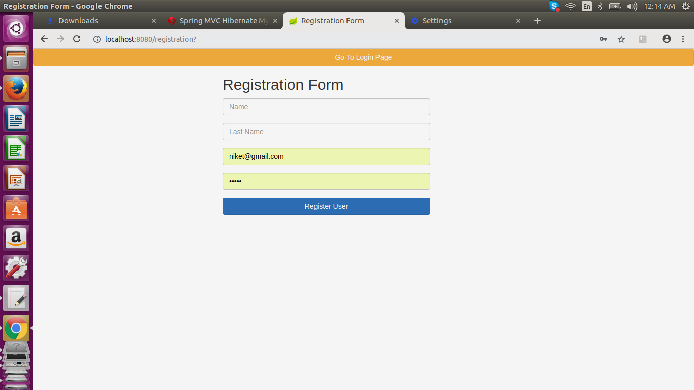

8. Add URL

9. URL you can list

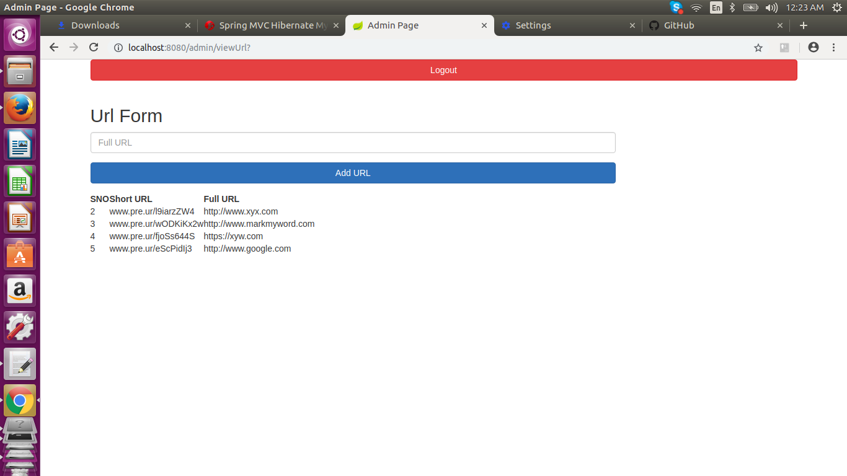

10 . This Code is used for calling as a Web Service.

@RequestMapping(value = "/api/addUrl", method = RequestMethod.POST)

public String apiAddUrl(@RequestBody ShortUrl shortUrl) {

urlShortService.saveShortUrl(shortUrl);

return "Url Added Sucess";

}